**Real estate blockchain creates visibility**

By developing cutting-edge solutions to optimize corporate operations, we support the real estate sector. You may incorporate blockchain into your real estate firm with the aid of our team of professionals.

**Blockchain's advantages for the real estate sector**

By utilizing Distributed Ledger Technology (DLT), blockchain facilitates more transparency while accelerating the contracting process, cutting costs, and saving time.

* **Asset Tokenization**

Tokenization of assets, a method of giving an investor a portion of a property using blockchain technology, would eliminate middlemen, improve transparency, and democratize investing.

* **Efficacy of the Process**

Commercial real estate (CRE) organizations may benefit from more effective operations, quicker payments, and cheaper expenses thanks to smart contracts and digital identities for title evaluation.

* **Mortgages, financing, and home loans**

Blockchain may be configured to contain pertinent data to enable future servicing choices by digitising loans or mortgages.

* **Public Title Management**

With blockchain, digital assets take the role of paper deeds, and all transactions are recorded on an immutable ledger, ensuring total transparency for all parties.

**Brugu's standard Solutions for the Real Estate Industry**

As a premium blockchain giant, Brugu has found a lot of solutions for problems which their competitors have hard a hard time to find any solution. Being the frontrunners in this field, Brugu has standard solutions for major problems. Here are few:

**Administrative Control**

Thousands of data, including images, documents, and other corporate material, may be stored using our cloud-based solutions, making it easier to produce thorough reports.

**Accessibility Control**

We are skilled in developing IoT systems that provide real-time data access and enable extensive analytical reports to improve the end-user experience.

**Security Administration**

Transactions may be made more transparent and safe with the help of our blockchain technology solutions thanks to cutting-edge end-to-end encryption.

**Facilities Administration**

By utilising cutting-edge and cooperative project management technologies, we provide the highest calibre of client service.

**Development of digital wallets and tokens**

Whether it's JavaScript, TypeScript, Go, Solidity, or Node.js, we have the same language as you. Using angular, react, ionic, and other frameworks, our skilled developers can assist you in creating safe, fully compliant digital wallet apps.

**Our Approach to Development**

**Post Your Question**

We will evaluate the needs of your project and provide an expert engineer or consultant who is most equipped to help you go forward.

**Analyst Conversation**

When it comes time for us to start working on your project, one of our professionals will get in touch with you to thoroughly go through your needs.

**Terms & Conditions of Engagement**

The following phase will entail negotiations with a committed project manager who will outline the precise nature of the job, delivery dates, payment conditions, timetable, management issues, etc.

**Start now**

Following agreement, we execute a contract, and our staff will begin working on your project within 24 hours.

**Why Engage Us For Blockchain POC Development?**

**Ingrained Experience**

We have extensive knowledge and technological experience to create cutting-edge digital contracts with completely adjustable features that are suited for all businesses.

**24 Hour Client Service**

Post-adoption assistance helps smooth the transition, handle adoption concerns and test stability in the early days. Alignment with time zone and process requirements are seamless.

**Cutting-Edge Technology**

We deploy cutting-edge technology, digital protocols, tools, and platforms to improve process transparency and speed up claim settlements.

**Governance and Compliance**

Complete conformity with business policies and laws. Solid documentation to help governance post-implementation.

**360-degree Assistance**

We offer complete smart contract consultancy, Ethereum programming, dApp design and development, and post-deployment maintenance.

**Competence in the industry**

Deep knowledge of many industry-specific procedures, as well as competence in implementing the full range of Blockchain solutions.

**FAQs:**

**What is real estate on the blockchain?**

Blockchain is a digital ledger that serves as a single source of truth in the real estate industry, democratising access and boosting confidence. For real estate investors, this has broad ramifications.

**What role does blockchain play in real estate?**

Imbrex is a listing platform that decentralises and encrypts data using blockchain technology. In order to promote transparency and lower barriers in the buying/selling process, it directly links buyers with listing agents and pays them in digital tokens rather than cash.

**Real estate agents may be eliminated via blockchain.**

Many financial and legal restrictions are removed by the transparent and secure nature of blockchain technology. You may buy complete houses using bitcoins on some blockchain platforms.

**Grammarly screenshot:**

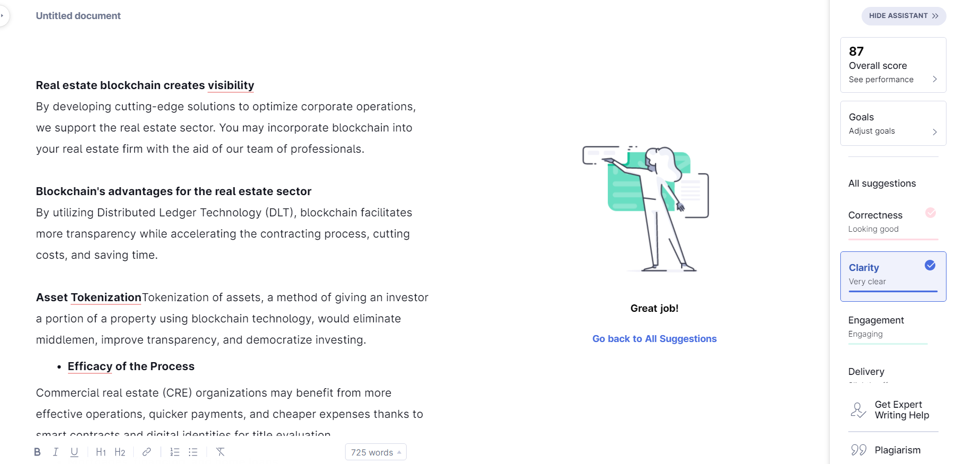

**Plagiarism checker:**

